Activation/Inhibition

Cellular Automata

Samuel Leonard

COSC 420

21 February 2019

# Introduction:

The objective of this experiment is to test several different combinations of the five parameters and investigate their effect on the quantitative measures and the qualitative behavior of the system. Throughout the experiment different radii (r1 and r2), activation and inhibition (j1 and j2), and bias (h) will be used to observe the image output and calculate the automata correlation, entropy, joint entropy, and mutual information amongst cells. This data will be used to draw conclusions based on the relationship of the calculations and the images produced.

# Theory:

How does the automata behave when the two radii are closer together? How do they behave when they are farther apart? What affect does bias have? Does changing the activation or inhibition produce different results? What affect will changing the parameters have on the correlation and mutual information? How does it change the image?

When the radii are closer together, the automata should be more chaotic and even more difficult to produce images that are not all black or all white. The entropy for these should be lower as there is a greater disparity in blacks and whites. The further apart the radii are, the more complex the outcomes. There should be less disparity unless there is a bias and the entropy will be closer to one. The bias should put a greater emphasis on the positive and negative outcomes and produce images that are whiter or blacker. This indirectly will affect the average entropy. If there is an affect on the overall entropy, then the mutual information will be affected because average entropy is used in its calculation. The greater the distance between cells, the lower the correlation will be, all other values being equal. Also, utilizing the correlation formula, the more white or black an image is, the higher the correlation, again all other values being equal. Increasing the activation should produce more local uniformity, shorter patterns while decreasing it should produce less. Increasing the inhibition should create more separation and longer patterns while decreasing it should demonstrate patterns that are closer together.

# Methods:

To acquire this data, a computational program needed to be written. This program needed to produce cellular automata that changed based on the parameters mentioned above. The cells of the automata were represented by a 30 by 30 matrix that was initialized to -1 or 1 randomly. After initialization, each cell is then processed to see whether it should be updated. The program chooses these cells randomly and only picks cells that have not been updated for the given time step **t**. The formula below (**Equation 1**.) is used to determine whether the sign of the cell should be changed.

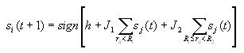

Equation . Calculates the Sign Change for Each Cell

This formula sums the values of each cell within the two distances of the cell currently being processed. The program accomplishes this by traversing through every cell in the matrix and calculating the distance between these cells and the chosen cell currently being processed. This is accomplished using the distance formula below in **Equation 2**.



Equation . Calculates the Distance between Two Cells

The updating process continues until all the cells have stabilized. This is a two-step process in the program. First, each cell has been checked using **Equation 1** and updated if the sign of the cell value has changed for the given time step. Second, during each time step the states are evaluated to see if at least one state did update. If no state updated for the last time step, then the matrix has stabilized. Once stabilized, an image of the stabilized automaton is produced. This is done by giving a black pixel value (0) for cell states that are **1** and a white pixel value (255) to cell states that are a **-1.** Now that the automaton has stabilized the program could compute the values for **correlation (rho_l)**, **entropy (H_s)**, **joint entropy (H_l)**, and **mutual information (I_l)**. For the **correlation**, the formulas in **Equation 3** and **Equation 4** were implemented.

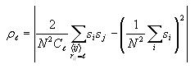

Equation . Calculates Correlation for Distances not Zero

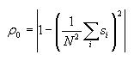

Equation . Calculates Correlation for Distance Zero

The program computes the correlation for each distance [0-14] by summing the products of the cell being processed and any cell that is at the current distance being evaluated. The summation is then multiplied by a coefficient that averages the value for that distance. Then, the average value for the entire matrix is subtracted from the equation and the absolute value is taken. This is accomplished by **Equation 3**. If the current distance is zero, then the **Equation 4** is used. For each distance, the correlation value is stored in an array.

Next, the program makes the average **entropy** calculation using the formulas in **Equation 5**.







Equation . Formulas to Calculate Average Entropy

The beta element in the first formula of **Equation 5** converts the cell value to a **1** or a **0**. So, rather than compute the beta conversion each time, the program just sums the cells that have a value of one. This sum is divided by the total number of cells to obtain a probability for the number of 1’s. To achieve the probability of -1’s, the probability of 1’s is subtracted from one. The program then computes the average entropy using the third formula in **Equation 5**.

Once the average entropy has been calculated, the next process is to compute the **joint entropy** for cells that are a distance [0-14] away. Using the formulas in **Equation 6**, the program sums the products of cells at the current distance checked where both cell states are **1**. Then, this is performed for cell states that are both **-1**. This gives the probability for two states having a value of one and the probability of two states having a value of negative one.

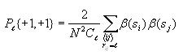

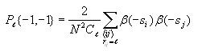





Equation . Formulas to Calculate Joint Entropy

The program uses the third formula in **Equation 6** to find the probability of the two cells having different values. The last formula can now be used to calculate the overall joint entropy for a specific distance. The value is then stored in an array for joint entropy indexed on that distance.

The last computation the program makes is the calculation for **mutual information**. The formula is given below in **Equation 7**.



Equation . Formula for Calculating Mutual Information

This calculation is simple. For each distance, the program multiplies the average cell entropy by 2 and then subtracts the joint entropy for that distance. The value is stored in an array indexed by that distance.

The program performs the steps above four times for each experiment and then divides each result by four to obtain the average and outputs these values to an excel file (.csv).

The parameters (r1, r2, j1, j2, h, exp_name) for these experiments are input from the command line when the program is executed allowing for variations of these parameters to be tested. This allows for testing the effects that changing the parameters (exception of exp_name) has on the correlation, joint entropy, and mutual information of the automata. The program also produces an image of the automata in their stable state for comparison as well. Graphs are made from the excel data to make comparison a little more intuitive. Utilizing these tools has made testing the hypothesis much easier and more reliable.

# Results and Discussion:

Here are the graphs for **correlation**, **joint entropy,** and **mutual information** for each experiment. Next to the graphs is the corresponding image for that experiment. The graphs show their values for distances between 0 to 14 inclusive. Each graph has at least one varied parameter that is different than the others. As the graphs and images are compared, the results as well as discussion will help answer the questions given in the theory segment above. This should help to determine how accurate the assumptions that were made are. First, a look at **bias (h)**.

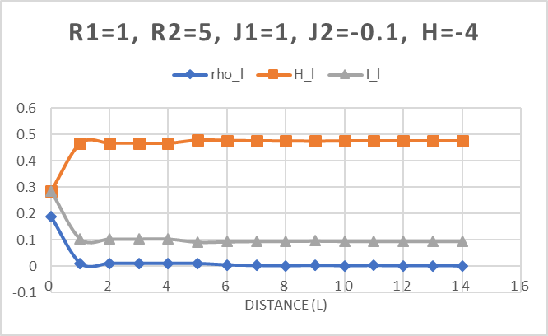Figure 1: Experiment 1 Graph and Image

The images in **Figures 1-4** demonstrate the effect of **bias** on the automata. The image in

**Figure 1** has a negative value for its bias and as a result the image has more white pixels. Using the formula from **Equation 1**, the bias is added to the overall result, therefore causing more cells to have a **-1** value. The negative value is converted to white in the image above.

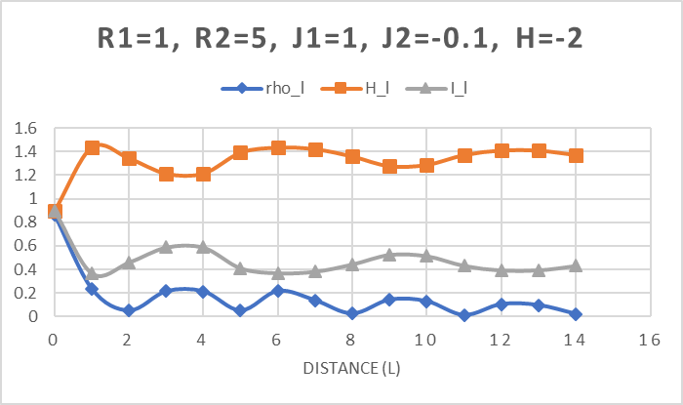Figure 2: Experiment 2 Graph and Image

The images in Figures 2, 3, and 4 show how the image produces has more blacks as the bias grows more positive.

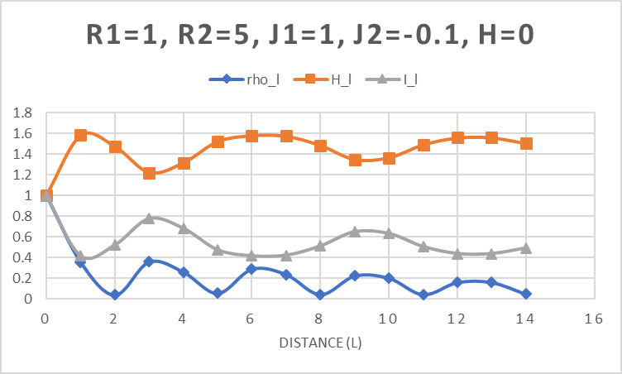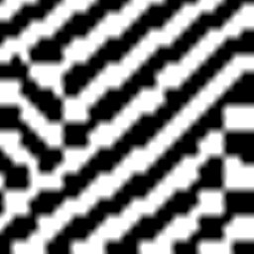Figure 3: Experiment 3 Graph and Image

**Figure 4** has very little white left but still manages to maintain its complex behavior. This most likely is caused by the fact that there is a decent amount of distance between the two radii. This will be discussed more later.

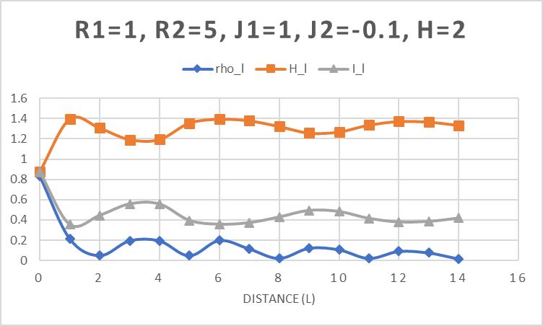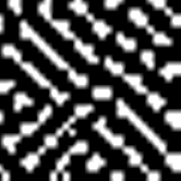Figure 4: Experiment 4 Graph and Image

Below are some more images (**Figures 5-9**) that make it apparent how bias works.

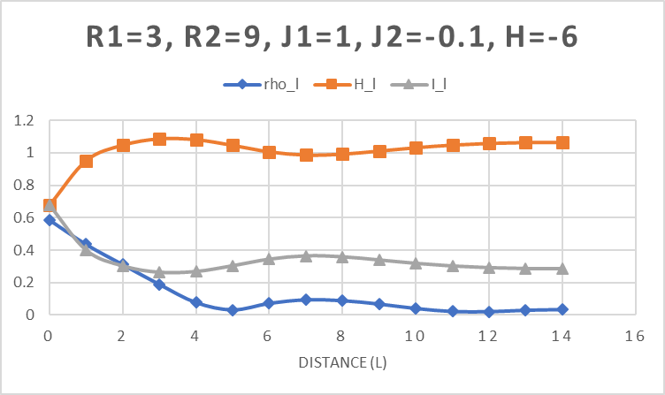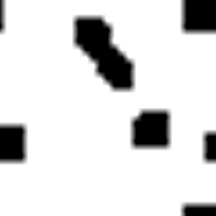

Figure 5: Experiment 16 Graph and Image

Again, notice the bias value of -6 and the whiteness of the image. Each succeeding image will continue to display more blacks as the bias becomes more positive.

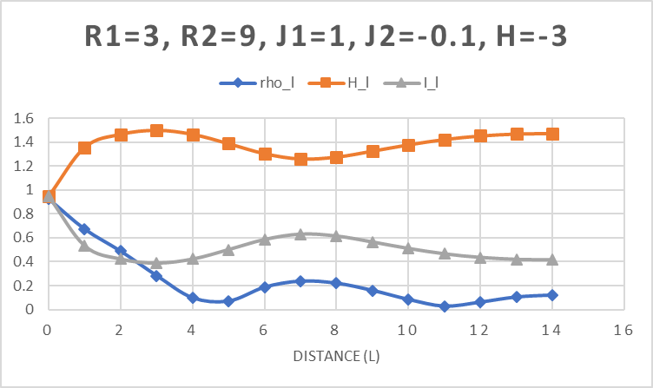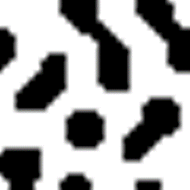

Figure 6: Experiment 17 Graph and Image

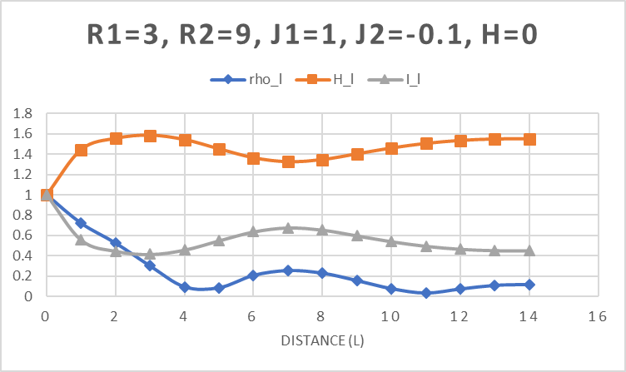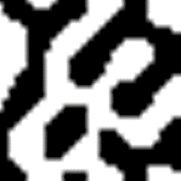

Figure 7: Experiment 18 Graph and Image

**Figure 7** shows an image where the bias is neutral. There is no negative or positive influence.

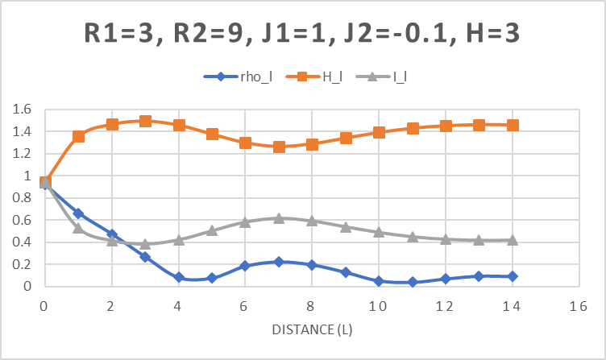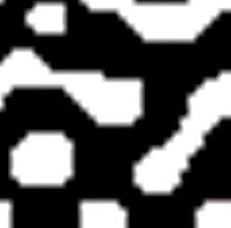

Figure 8: Experiment 19 Graph and Image

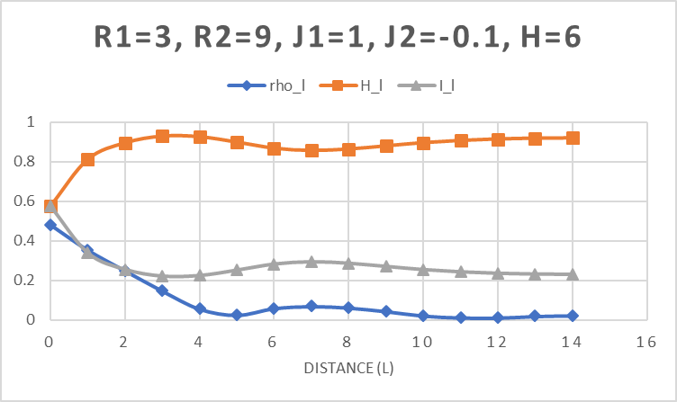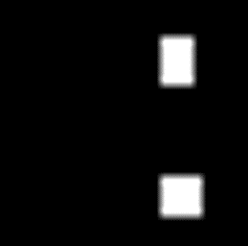

Figure 9: Experiment 20 Graph and Image

In **Figure 9**, notice how black the image is when there is a heavy positive bias. The bias for this automaton is 6. Most likely, some white still exists because there is a distance between the radii of 6, otherwise this image may have been all black. So, how does distance play a role in the outcome of the automata and images?

Smaller distances between radii produce more chaotic, less complex behavior. There are less groupings and more sporadic results.

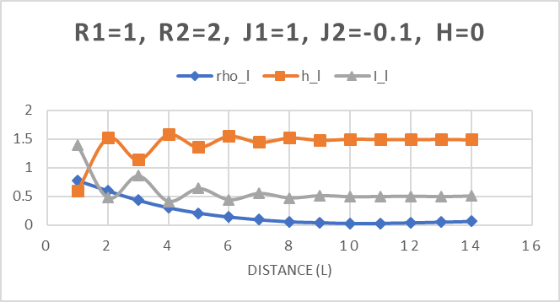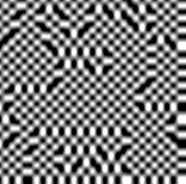

Figure 0: Experiment 0 Graph and Image

The image in **Figure 10** demonstrates how a very short distance between the radii produces a more chaotic image. This also shows an image that appears more binary. Even though there are only two states a pixel can have, this image only excepts a binary range of distances as well leading to this very interesting pattern. However, any variance in the bias and the image becomes all black or all white. **Figures 11** **and** **12** show distances that are very close together but have higher **r1** and **r2** values.

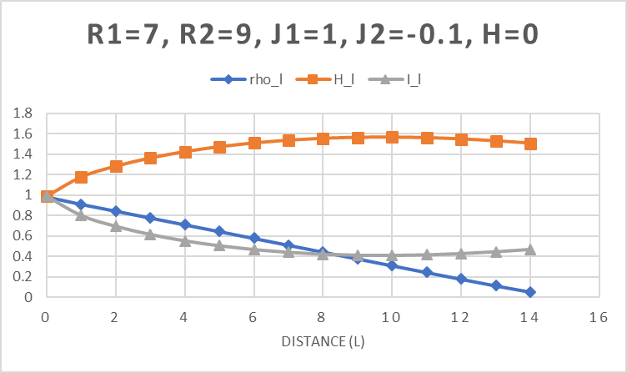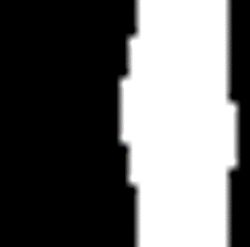

Figure 11:Experiment 27 Graph and Image

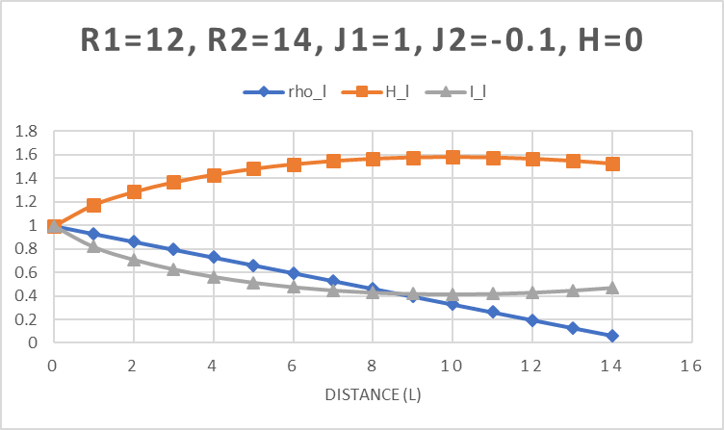

Figure 1: Experiment 32 Graph and Image

Both these images have short distances between the radii and produce a less complex, more linear image. Look at the correlation values for these images. In both instances the values are linear. The joint entropy and mutual information values also have very little fluctuation. This is somewhat different from **Figure 10** which does have fluctuation in its graph curves.

This shows the behavior of short radii distances but what about larger separations between **r1** and **r2**? Greater areas of interaction produce larger and thicker patterns. The interactions reach farther, and more data is involved in the update of each cell. **Figure 4 and 7** located above show the thickness and length with a radii difference of four and 6 respectively. There are many structures, but they are a lot thinner. The images below in **Figures 13, 14, and 15** show how the patterns change as the radii difference gets larger.

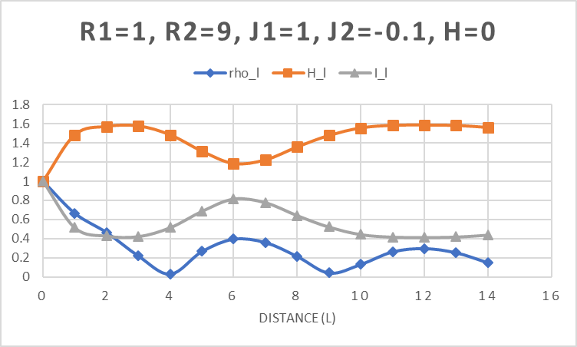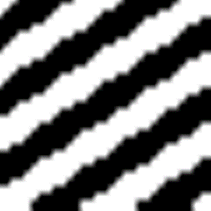

Figure 1: Experiment 7 Graph and Image

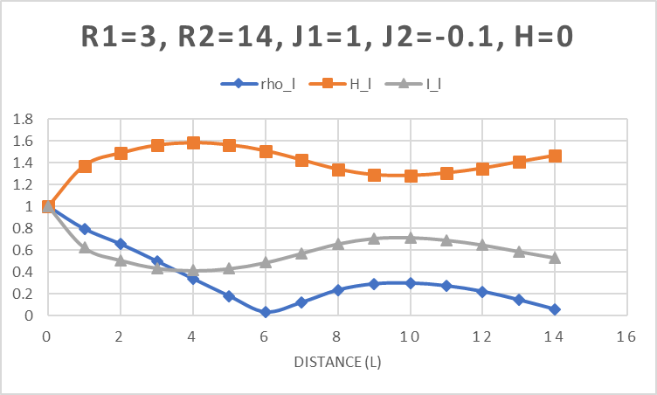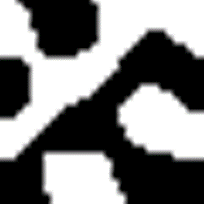

Figure 1: Experiment 23 Graph and Image

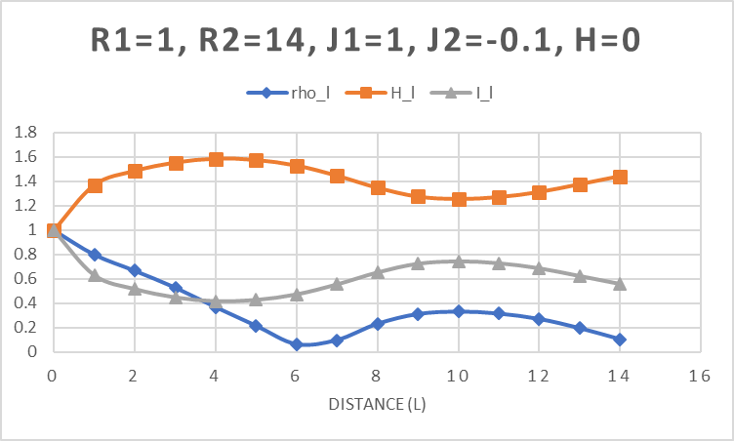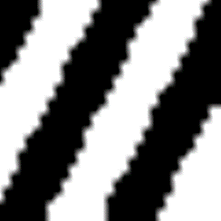

Figure 1: Experiment 12 Graph and Image

Notice how the patterns are thicker and, in most cases, longer. **Figure 14** is eccentric in appearance but notice the thick rounded patterns. Looking at the update formula in **Equation 1**, it is easy to see that the greater the distance between **r1** and **r2** the greater the distance of influence on the cell being updated. The sum of the values for distances between the two radii are multiplied by the **inhibition** factor which is responsible for the diffusion to farther distances.

What does correlation and mutual information mean, and how are they affected by the parameter inputs for the experiments? Correlation is used to describe the linear relationship between the cells. Values closer to 1 indicate a stronger relationship while values that are closer to 0 indicate a weaker relationship. Mutual information measures the degree in which the two cells are independent. Values closer to 0 indicate more independence while higher values demonstrate more correlation and predictability. Look at **Figure 1** above, the correlation and mutual information values are low and have leveled off. There is little information to determine what the next cells may be. Now look at **Figures 13, 14, and 15**, the mutual information is much higher demonstrating the information about the cell helps in predicting information about the state of next cell and so on. The more complex the automata, the more fluctuation there is in the correlation and mutual information. The less activity in the automata, the more linear the values become.

**Activation** and **inhibition** determine the diffusion that takes place at shorter and longer distances. So, how does varying the activation and inhibition affect the automata and their images? In **Images 1, 2, and 3** below, removing the activation produces images that look similar to the images that were produced when the activation was active, but now the images seem a little less stable.

  

Image 1: Experiment 35 Image 2: Experiment 37 Image 3: Experiment 40

When comparing images like those in **Figures 3 and 15**, there are some subtle differences. Look at the formation of squares in **Image 1** and the breaks from uniformity in **Image 3**. It is apparent that removing the activation lessens the local uniformity in the automaton and the image.

# Conclusion:

Producing graphs and images has helped answer several questions about what happens to cellular automata when their parameters are changed. Varying the bias will create a more negative or positive automaton based on whether the value is negative or positive. This will produce images that are blacker if the bias is positive and whiter if negative. Increasing and decreasing the distance between the radii increases and decreases the interactions with other cells. Greater distances produce more complex images and lesser distances produce more chaotic or linear images. Correlation describes the relationship between cells. Cells that have values closer to one have a strong relationship while values closer to zero have a weak relationship. Mutual information determines cell independence. Cells with high values are heavily correlated while cells with values closer to zero are more independent. Increasing the distance between radii increases the fluctuation in correlation and mutual information values which provides more predictability in what the next cell states will be. Turning on and off the activation and inhibition parameters removes the effects of one of the radii from the update formula. By varying the parameters within an activation/inhibition cellular automaton, like in nature, some very interesting patterns can be produced.